Öğrencinin;

ADI: Moaaz

SOYADI: Ahmed

NO: 1421221039

BÖLÜM: Computer Engineering

Projenin;

KONUSU: Linux thread senkronizasyonu ve prosesler arası iletişim

Dersin;

ADI: Operating Systems

EĞİTMEN: Samet Kaya



İçindekiler

1- Özet 3

2- Proje Konusu 3

3- Proje Çıktıları ve Başarı Ölçütleri 4

4- Proje Süresince Yapılanlar 5

5- Ek Açıklamalar 5

6- Kaynakça 5

# Özet

In this project I am reading data from data.txt file recursively till negative number is save in data file.

The numbers came from file being read by **threadReader** function, send to **threadCalculator** which take its square and add that square to general addition which will be printed to screen every time.

# Proje Konusu

The main perpose of this program is to implement an algorithm that do the follow:

reader :

reads data from data.txt file

readThread:

reads from data, control these numbers if negative exit the whole program.

calculateThred:

gets numbers from readThread takes its square and add it to general addition, which will be printed to screen at every adding time.

# Proje Çıktıları ve Başarı Ölçütleri

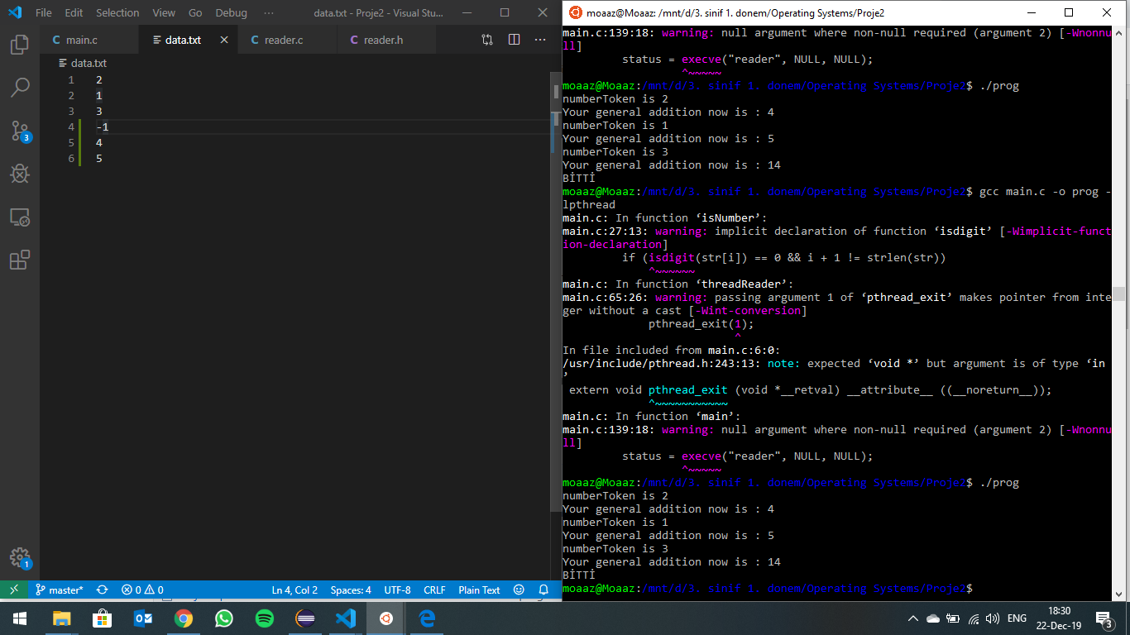

# Proje Süresince Yapılanlar

* First the read program executed from a to z and this took much long, then when executing threads it take less than first one as most of operations were executed.
* The project is uploaded to github link provided, as it can be traceable for everyone. [Linux_thread_senkronisation_and_communication_between_processes](https://github.com/MoaazGaballah/Linux_thread_senkronisation_and_communication_between_processes)
* Make file operations and report were the last tasks did during that project.

# Ek Açıklamalar

During this project the most challenge tasks was to get, operate and handing in fork, pipe and threads together through command line window using Objective-c programming language.

I think it’s because I had to handle that code with memory directly my self knowing every inch of the memory, what have and what haven’t, also what have but not for use and so on.

That was a very good experience for me to do such a project

# Kaynakça

* <https://github.com/>
* <https://askubuntu.com/>
* <https://www.quora.com/>
* <https://stackoverflow.com/>